Two Rivers Primary School
Independent Skills
Aspirations
At school we will be working with the children to teach and enable them to develop these independent skills during their time with us. Please take a look and work on these skills at home also.
These have been split into Sensory Provision and Year groups in school.

Sensory Curriculum
Stage 1
- Indicate they want more by unintentional vocalisation
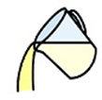
- Indicate they want more by unintentional movements
- To take food off their spoon with their mouth
- Open their mouth to accept food
- Drink from a cup or bottle when held for them
- To hold a cup and tip to their lips and drink
Stage 2
- Taking turns with support
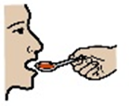
- Waiting with support
- To take food off their spoon with their mouth
- Recognise their own cup
- Using cutlery – to scoop or spike their food
- Hold a cup independently
- Lift a loaded spoon
- Lift a loaded spoon to their mouth
Stage 3
- Taking turns in an adult led activity
- Waiting patiently for up to 1 minute
- Indicate they want more through sign or speech
- Show likes and dislikes

- Use of More switch to ask for more
- Using PECs to make choices from 2 (high and low motivator)
- Trying new and different foods, showing liking or not liking
- Hand cup to adult when asked
Stage 4
- Using PECs to make choices from 2
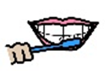
- Using PECs to ask for what they would like
- To recognise the lunchtime symbol on timetable
- Using PECs to make choices I want …….
- Recognise their own cup
- Recognises that its dinner time through routine
- Recognises lunchtime song
- Recognises dinner lady
- Uses their senses to indicate its dinner time e.g. sounds and smells
- Recognises their lunchbox
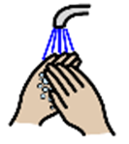
Stage 5
- Use “more” switch
- Sign “more”
- Indicate they have finished
- Sign / say “finished”
- Uses a flannel to wipe their face
- Washes hands
- Dries hands
- Spread butter on toast

- Spread jam on toast

Stage 6
- Cut their toast
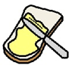
- Drinking independently
- Hold a cup independently
- Using an open cup
- Sitting at a table for the whole meal
- Put lunchbox away
- Using cutlery – to scoop or spike their food

EYFS

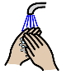
Personal care
- Attempt to wash hands for lunch
- Tolerate their teeth being brushed after lunch (support from adult)
- Tolerate their face being washed after lunch
- Place arms through coat, within minimal support
- Able to be dressed and not resist
- Able to hold my arms out for sleeves
- Able to put my foot up for shoes
- Able to pull my socks off
- Able to remove my fastened coat
- Able to remove my shoes when unfastened
- Able to push down my pants
- Able to find arm holes in a t-shirt
- Passive during toileting
- Can show awareness of the routine of nappy change
- Show awareness of routine of going to the bathroom
- Show awareness when nappy is wet/ soiled
- Actively helps with bathroom routine (toilet trained or nappies)
- Can sit on the toilet
- Occasionally urinate on the toilet
- Occasional bowel movement on the toilet

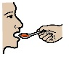
Life skills

- Acknowledge when it is lunch time (use of song or symbol)
- Drink from a lidded beaker
- Open mouth in anticipation of food/drink

- Take pureed/lumpy/solid food from a spoon
- Can take food with their fingers
- With support bring loaded spoon to mouth
- Can bring preloaded spoon to mouth
- Attempts to load their own spoon
- Load their own spoon
- Use a spoon to feed themselves
- Begin to hold a piece of cutlery in each hand
- Wear a coat for outside play (when needed)
- Wear shoes for outside play
- Wear a reasonable amount of clothing
- Locate their coat and peg using photos
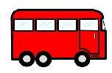
Community visit

- Experience new outdoor/indoor environments
- Tolerates new outdoor/indoor environments
- Know to hold hands with an adult
- Listening skills begin to develop
- Early level following instructions

Years 1-2

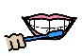
Personal care
- Independently find their tooth brush and brush the front of their teeth
- Know when to wash their hands
- Wash their hands with soap and dry properly
- Attempt to wash their face with a flannel after lunch – use of mirrors to check

- Put on their coat and complete the zip once placed in holder
- Able to pull on my socks from the heel
- Able to put on t-shirt with little help
- Able to push feet into unfastened shoes (not always correct feet)
- Able to unbutton large buttons
- Can have some awareness of needing the toilet but not always say in time
- Can say/ go to the toilet in time
- Can wear pants ½ day successfully
- Can be dry all day
- Has good bladder/ bowel control
- Can attempt to clean themselves after visiting the toilet
- Can successfully clean themselves after visiting the toilet
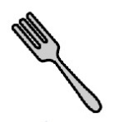
Life skills

- Attempt to use a fork
- Can use a fork appropriately
- Attempt to cut their food
- Hold a knife and fork during lunch time
- Drink from an open cup
- Attempt to spread butter on toast

- Locate their coat, bag and peg throughout the day taking some responsibility for belongings

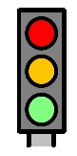
Community visit

- Experience new outdoor/indoor environments
- Tolerates new outdoor/indoor environments
- Accesses the community with the support from an adult
- Basic knowledge of traffic lights and their purpose - red/ green light
- Ability to stop when asked by the adult
- Walk with a partner

Years 3-4
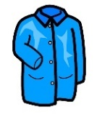

Personal care
- Zip up their own coat
- Brush their teeth after lunch, applying tooth paste and brushing a good proportion of their mouth independently
- Use mirrors to check if they need to wash their face and independently do so after lunch
- Able to put on t-shirt
- Able to pull on my socks, heel may be in wrong place
- Able to remove t-shirt
- Able to button up large buttons
- Able to find front of clothing
- Able to snap clothing on the front (press stud)
- Able to unzip front zipper (separate zipper)
- Able to step into trousers the right way
- Can successfully visit the toilet by themselves, including getting dressed and cleaning themselves
- Can flush the toilet after use
- Can wash and dry their hands after visiting the toilet

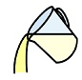
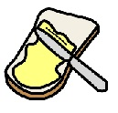
Life skills
- Use a knife and fork to push food on to their fork
- Slice/ cut their own vegetables
- Spread butter on toast and cut it in half
- Pour their own drink

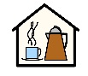
Community visit

- Experience new outdoor/indoor environments
- Responds appropriately to new outdoor/indoor experiences
- Accesses the community alongside an adult
- Behaves appropriately in a café
- Behaves appropriately in a shopping environment
- Uses a shopping list with adult supervision
- Know where they live, able to give first line of address
- Aware of who to call in an emergency and how to do this
- Know how to cross the road safely using traffic lights

Years 5-6
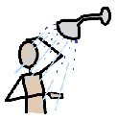
Personal care

- Using a shower including drying themselves
- Awareness of deodorant, bodywash, shampoo
- Brushing their hair – use of bobbles, hair bands etc
- Tying shoe laces
- Fastening and unfastening buttons (shirts and trousers)
- Put on gloves
- Able To button 3-4 buttons in sequence
- Attempt to buckle shoe or belt
- Able to connect zipper
- Able to put on socks the right way
- Able to dress without help or supervision
- Able to put on jumper correctly every time
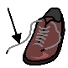
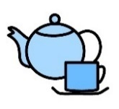
Life skills

- Use cutlery correctly to feed themselves
- Make their own drinks
- Hoovering
- Grating, peeling, chopping in food prep

- Planning a meal – balanced diet
- Making a cup of tea
- Washing up
- Using the washing machine
- Pegging clothes on washing line
- Able to choose appropriate clothing for weather/ situation

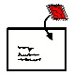
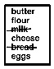
Community visit

- Experience new outdoor/ indoor environments
- Accesses the community following road safety rules with adult support
- Shops with purpose with adult supervision
- Uses a shopping list
- Pays for items with adult’s full supervision
- Learning their address, how to present it on an envelope
- Using stamps and post boxes
- Learning phone numbers
- Dialling people to actually speak to someone
- Using a bus – looking at which number bus they need, begin to use timetables (if can tell time)
- Money – To know the value of each coin
- Cross the road safely using lights or zebra crossing

