I Can Share With My Friends

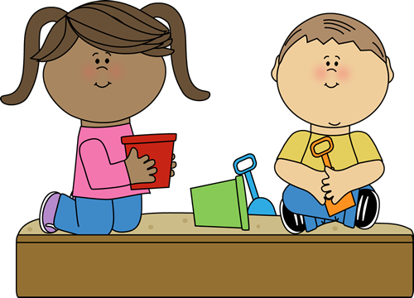

Kelli Harrison
Social Stories for those on the Autism Spectrum



I love to play with toys and games. I like to play alone sometimes too.

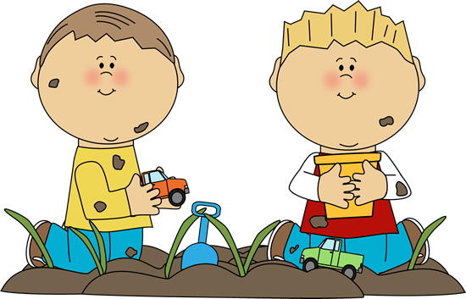

But I love to play with friends even more! We can have fun and play together.

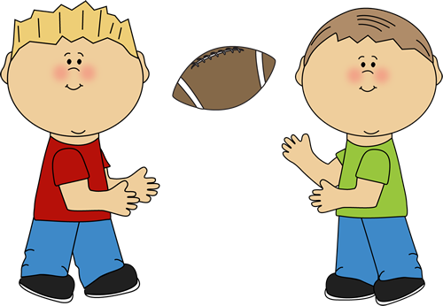

When I play with friends, I have to remember to share my toys and take turns with them.
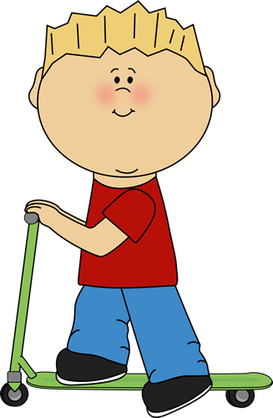

I can ride the scooter.

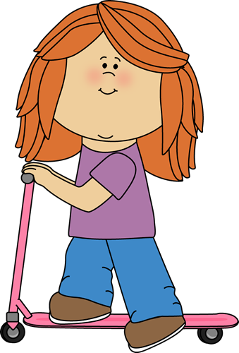

Then I can let my friend ride the scooter.

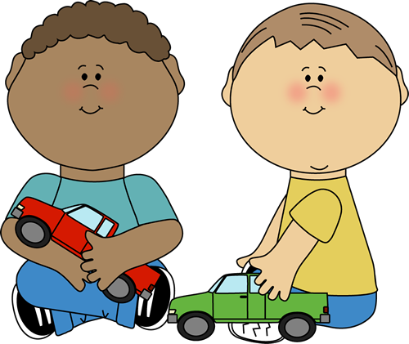

My friends and I can share toys while we play together. I can play with the green truck while my friend plays with the red truck.

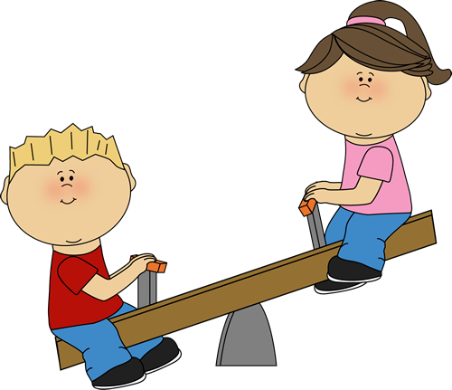

Sharing and taking turns with my friends makes me and my friends feel happy!

Thank you for purchasing this product!

I hope you enjoy it and that it helps your children. Looking for more stories or want to have a specific one written for you? Shoot an email to:

kelliwritesstories@gmail.com

Terms of Use: All rights reserved by author, Kelli Harrison. This product is to be used by the original downloader only.

Clipart largely provided by:


