Two Rivers High School
Torc campus, silverlink road, glascote heath
tamworth, staffordshire, b77 2hj
01827 426124

Assistant Headteacher
Pastoral support And sixth Form lead

Dear Applicant,

Thank you for your interest in the post of Assistant Headteacher – Pastoral Support and Sixth Form Lead at Two Rivers High School in Tamworth, Staffordshire.

Our special school is unique and our dedicated team work diligently, striving relentlessly to raise standards and attainment for our pupils. The school supports mainstream high schools in Tamworth.

Each child is an individual with different needs and we aim to provide a personal approach to each child’s learning. This is achieved by employing highly trained teachers and support staff who are committed to giving every child the extra support they need. We have created a positive, happy and safe learning environment where everyone is valued equally.

This role is challenging and you will be responsible for the well-being of our student population delivered in a safe, secure and supportive environment.

The successful candidate will be part of our experienced and dedicated Leadership Team reporting directly to the Head of School, Miss Gail Brindley.

Two Rivers is an outstanding school and we are looking for applicants that stand out from the crowd. You will bring sound knowledge and proven experience in special educational needs, together with strong management skills and the ability to be flexible and caring and enjoy being part of our team.

If you recognise the impact that quality educational provision and teamwork can have on enhancing the ability and achievements of every pupil, then we encourage you to apply.

Good luck!

Tony Dooley
Executive Headteacher

BACKGROUND INFORMATION
Two Rivers School was formed in September 2005, when the two special schools in Tamworth federated to create a new generic school. The school is split on two sites, one for primary aged pupils and the other for secondary aged pupils. As a federation we have one Executive Headteacher, one governing body but two budgets.

Prior to the federation both schools had been very well regarded within the local community, by the Local Education Authority and by Ofsted. We have received the Quality Inclusion Mark, Gold Arts Mark, Dyslexia Friendly Status, Healthy Eating School, CPD Mark and PE Active Mark. The High School has achieved Dyslexia Friendly Status at Level 1 and currently working towards recognition at Level 2. These are tremendous awards that reflect the excellent quality of education that we strive to offer our pupils.

The school is an integral part of the local community in Tamworth and the wider area; our pupils take part in a wide variety of projects including supporting Residential Homes, Tamworth Community Garden and the local allotments. Links with Staffordshire Partnership and local businesses offer opportunities for work related learning. Our sixth form benefits from many vocational subjects such as Engineering, Hair and Beauty and Retail. Work Experience has developed in the sixth form to include Cadbury World and Solus Coaches.

HIGH SCHOOL SITE
The High School opened in 2008 on a campus shared with Tamworth Vocational Centre, professionals from a range of support services and Tamworth’s Assessment Nursery. South Staffs College are now our campus partners, offering predominantly vocational courses for students interested in the building trades.

The facilities equal any High School including a Sports Hall, ICT Suite, Music Room, Performing Arts Room plus a Theatre, Science Lab, Therapy Room, and a room that caters for pupils with profound learning difficulties. Indoor courtyards provide a relaxing ambiance to the school.
Outside the school there are tennis courts, football pitches as well as seated areas. The playing fields lead to Tamworth Athletics Stadium.

TEACHING AND LEARNING
The High School is a large provision with over 170 pupils on roll. We provide an enhanced staff pupil ratio with pupils with the most complex needs being taught in smaller class groups. All classrooms have computers, iPads and interactive white boards to enhance pupils learning. There is sensory provision for those pupils not able to access the National Curriculum.

The High School delivers the curriculum through a secondary model. Much of what is delivered beyond the core subjects resembles the best practice found in alternative provision utilising a range of accredited courses.

The school has been involved in local and national competitions and has regularly out performed mainstream schools.

At Key Stage 4 & 5 pupils are entered for a wide range of external accreditation. This includes Unit Awards; Entry Level Certificates; Level 1 Certificates (GCSE); Duke of Edinburgh Award and Vocational Awards.

Pupils can transfer at YR11/12/13 or 14 to a college or wider community environment and are supported in that transition.

SAFEGUARDING
The health and welfare of all our pupils is paramount and taken very seriously. The school has rigorous safeguarding procedures and a nurse is based on the High School site. A range of alternative therapies and counselling are also available to support pupils’ emotional needs.

SCHOOL AIMS
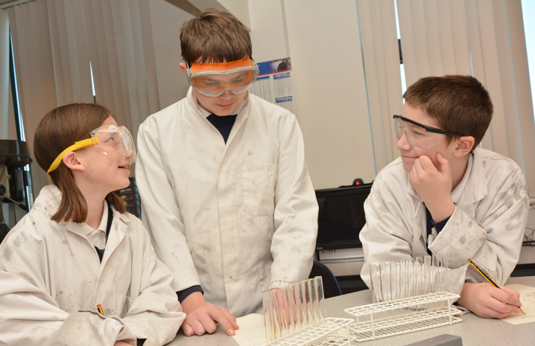
The school strives relentlessly to raise aspirations and attainment by providing high quality teaching and learning in a safe and secure environment in which the pupils’ welfare is paramount and where everyone is valued equally. The school promotes, encourages, supports and celebrates learning by ensuring:

- Excellent relationships between pupils, staff, parents and carers.
- High expectations for learners.
- Challenging, creative and age appropriate curriculum, relevant to the needs of the pupils.
- Positive, happy and motivating learning environment and culture.
- Holistic approach to the pupils learning, health and welfare is achieved.
- Strong links with the community.

- Confidence and self-esteem of all pupils is nurtured and combined with respect for others and understanding of responsibilities, self-discipline and high standards of behaviour.
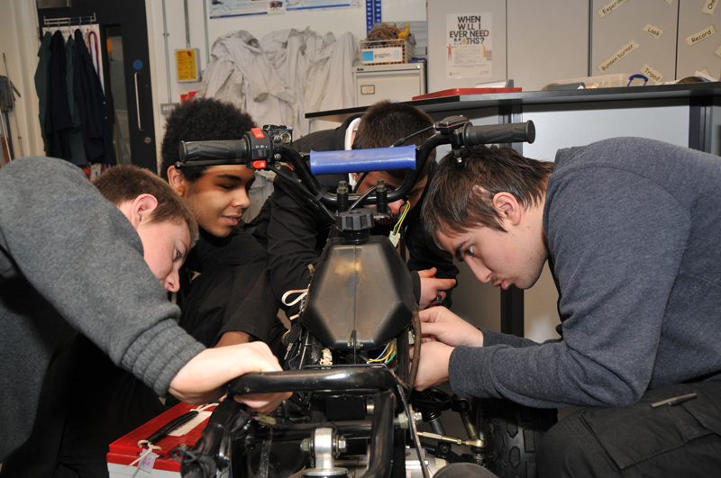
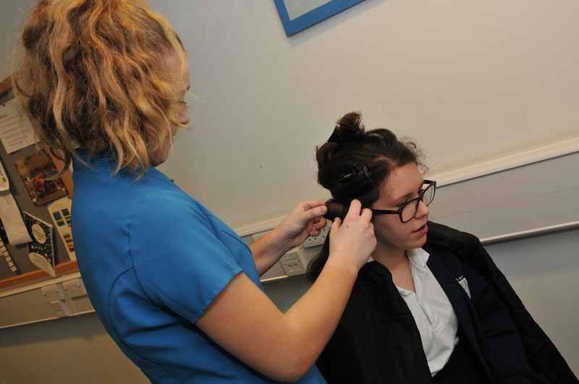
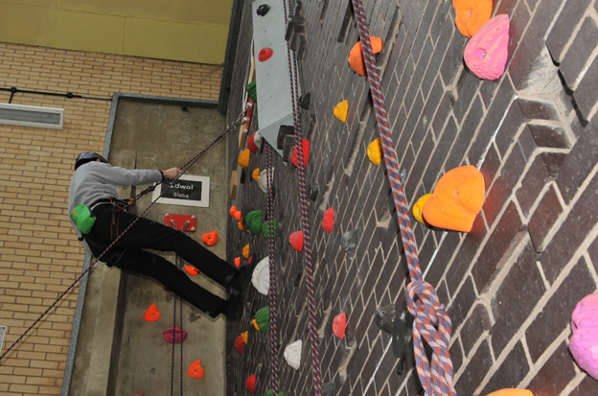

OFSTED
Our last Ofsted Inspection was in January 2019 confirmed that our school continued to be outstanding on every level. Here are some of the key findings from the inspection report which can be reviewed in full on our website:

“The leadership team has maintained the outstanding quality of education in the school since the previous inspection. Leaders have built on the strengths identified in the previous inspection report and have taken effective action to make further improvements.”

“Governance is highly effective because governors offer strong support and challenge to leaders”

“Pupils are taught well, and they have positive attitudes to learning.”

“Pupils in every year group make strong progress and move on to appropriate destinations when they leave the school.”

“Staff help to prepare pupils for life in modern Britain by developing pupils’ social skills and encouraging them to become as independent as possible.”

“Staff plan activities thoughtfully and have high expectations of all pupils”.

“Staff work well with parents and outside agencies to help to protect pupils, and pupils are taught to keep themselves safe in a range of situations.”

LOCATION
Two Rivers High School is located in Tamworth in South Staffordshire in the heart of the West Midlands. It is a large market town located only 14 miles from northeast Birmingham and bordering Warwickshire. The choice of housing location and leisure facilities is vast for any applicant needing to relocate to the area.

With a population of just over 76,000 on the last census, Tamworth is one of the largest towns in Staffordshire. With a great medieval history and once the Capital of the Ancient Kingdom of Mercia, a Norman castle still stands on a probable site of a Saxon fort and is an important tourist attraction.

Tamworth is easily accessible via the A5 and M42 and a local train station. Its location in Staffordshire makes it a workplace option for any applicant living within the County or in Birmingham, Stratford Upon Avon or Warwick.

This thriving and busy town offers a combination of historical attractions reflecting its rich past and a vibrant choice of modern attractions. As well as the castle, Norman Motte and Assembly Rooms, the National Memorial Arboretum, Twycross Zoo, Drayton Manor Theme Park and Snow Dome are all within easy reach. Shopping in Tamworth offers independent shops in the old town and new retail parks on the outskirts of the town with many high street superstores.

Tamworth has over 20 different suburbs with an average detached house selling for just under £290,000 and a semi-detached house for £180,000, with an overall average of approximately £200,000 (Source: Rightmove).

Assistant Headteacher – Pastoral Support and Sixth Form Lead

Salary: L11-L15 (£51,234 - £56,434)

Full time permanent position
Two Rivers High School is outstanding in every aspect of school life and we expect the same from our staff in pursuit of excellence in teaching and learning. We are a federated special school offering a challenging and creative curriculum to pupils with diverse abilities and needs, and are highly regarded by parents and carers and in the community.

Our new Assistant Headteacher – Pastoral Support and Sixth Form Lead will have the enthusiasm and commitment to maintain and raise standards, with the experience and knowledge of working with pupils with specific needs.

Starting in September 2019, you will bring:
- Experience as an established classroom practitioner who aspires to join an effective management team
- Understanding and knowledge of severe learning difficulties including ASD
- An imaginative approach to learning and the initiative to develop existing community and business links
- A range of people management skills and an ability to tackle issues and be accountable and responsible for decisions
- A track record of leading in whole/departmental initiatives

Two Rivers High School can offer you:
- The opportunity to lead in an outstanding school with a number of awards recognising our achievements
- Super pupils who enjoy learning and describe their teachers as ‘the best’
- Governors and leaders who are dedicated and effective, ensuring every pupil makes strong progress and succeeds
- A first-rate site with a range of facilities to enhance the learning

We are committed to the safeguarding and welfare of all children and young people. This post is subject to an Enhanced Disclosure and Barring Service check.

Closing date: Friday 5th April 2019

For an informal discussion or to arrange a visit, please contact Tony Dooley, Executive Headteacher on 01827 426 124

Further information: www.tworiversschool.net

APPLICATION PROCESS

Assistant Headteacher – Pastoral Support and Sixth Form Lead

Key Dates:

Closing date: Friday 5th April 2019

Shortlisting date: 11th April 2019

Interviews: Week Beginning 29th April 2019

Start date: September 2019

The school website will provide prospective candidates with further information about our school. (NB our school website is presently under refurbishment, if you are having difficulty accessing any information then please contact the school office).

We do hope that you apply and if you do, you need to submit a fully completed application form by the closing date as above. Please note that we do not accept CVs and no applications will be accepted after the closing date.

Shortlisting will be based on the information contained within your application form only.
If you wish to send an accompanying letter with your application, it should be no longer than one side of A4 paper.

Please email your application for the attention of Mr Tony Dooley, Executive Headteacher to: val.pickering@tworiversschool.net

For further enquiries, please contact the school on 01827 426 124

We look forward to receiving your application.

ASSistant Headteacher

Job Description

Reporting to: Head of School, Executive Headteacher
Executive Focus: Leadership and Management
Pastoral
Students’ Behaviour and Safety
Sixth Form Lead
Operational Focus: Pastoral Care; Behaviour and Safety; Attendance,
Pupils’ and Parents’ Voice

Key Responsibilities:
- To undertake the full range of professional duties in the Head of School’s and Deputy Head’s absence from school
- To undertake any professional duties of the Executive Headteacher and Head of School, reasonably delegated by them
- SLT lead on the provision and delivery of holistic and multi-disciplinary support to all pupils.
- Support the Head of School in ensuring that the school’s systems, organisation and processes are well considered, efficient and fit for purpose, upholding the principles of transparency, integrity and probity.
- Head of 6th Form (see specific responsibilities in Appendix 1)
- To lead and review on the implementation PROACT SCIPr-UK®
- Responsible for attendance of students and strategies/plans to improve attendance, including liaison with external agencies.
- Responsibility for the organisation, implementation and effectiveness of the school’s pastoral system
- Responsible for the preparation and suggested exclusion of students, including the preparation of any permanent exclusion documents.
- The main link between the school and parents, including the Friends Association, student council and voice.
- Educational Visits Coordinator (EVC)
- Liaison with LA on Home/School transport
- Any other issues or responsibilities as may arise or are identified by the school or Headteacher.

Strategic Direction and Development of the School:
- Developing and leading designated developments within the School Development Plan
- To communicate compellingly the school’s vision and drive the strategic leadership, empowering all pupils and staff to excel.
- Actively contribute to Two Rivers High School self-evaluation processes
- Act as team leader for the teacher appraisal process
- Challenge educational orthodoxies in the best interests of achieving excellence, harnessing the findings of well evidenced research to frame self-regulating and self-improving schools.
- To lead on reporting to governors on school improvement relating to attendance and pupil behaviour.
- Overseeing the review, management and implementation of the policies relating to the above-named areas of responsibility.
- Attend all relevant meetings that relate to the job description.

Leading & Managing Staff:
- To hold and articulate clear values and moral purpose.
- To strategically lead Middle Leaders on all aspects of school improvement with regard to pastoral issues, behaviour (including attendance) and safety.
- Promote a culture of inclusion within the school community where all views are valued and taken in to account
- To demonstrate optimistic personal behaviour, positive relationships and attitudes towards pupils and staff, and towards parents, governors and members of the local community.
- To lead by example - with integrity, creativity, resilience, and clarity
- Hold all staff to account for their professional conduct and practice.
- Provide a safe, calm and well-ordered environment for all pupils and staff, focused on safeguarding pupils and developing their exemplary behaviour in school and in the wider society.
- Organise and support the induction of staff new to the school and those being trained within the school

Effective Deployment of Staff:
- Participate as required in the selection and appointment of teaching and support staff, including overseeing the work of supply staff/trainees/volunteers in the school in the absence of the Head of School and Deputy Head.
- Line management of supervisory assistants and management of non-teaching time

Health and Safety Issues:
- To lead on the development of Individual Behaviour Support Plans as well as risk assessment for students
- To support the Safeguarding lead in all aspects of their duty where appropriate.

Teaching and Learning:
- To teach lessons as directed by the Head of School
- To take responsibility for the subject as directed by the Head of School

Appendix 1
6th Form Specific Responsibilities

Careers and Transition
- To line manage the careers and transition lead teacher
- To provide suitable transition packages for Y10 transition to Y11 and new students who transition into the school at Y11 or above.

Sixth Form Curriculum
- Planning an appropriate curriculum which covers academic, vocational, social, moral and personal care needs.
- Monitoring the progression of all areas of the curriculum which includes all option blocks to provide an accredited course.
- To hold staff accountable for student progress against targets.
- Monitor and evaluate the effectiveness of staff planning.
- To co-ordinate the delivery of exams and coursework with the support of the Examinations officer.

Timetabling
- To create a balanced curriculum of suitable options to meet the students’ needs which can be verified nationally.
- Planning, linked to whole school calendar.

Annual Reviews
- To undertake annual reviews for Y11 and above.

Pastoral
- To liaise with other members of the SLT and the Pupil Support with regard with any relevant students.
- To undertake any meetings with students, families and outside agencies depending on the students’ needs.
- To monitor student attendance and punctuality.
- To implement the Behaviour policy and provide sanctions where required for the 6th Form.
- To monitor the implementation and review of IBSP and Risk assessments.

Reporting
- To monitor the implementation and review the writing of IEP’s and ILP’s.
- To monitor all reports to parents and write End of year report comments ensuring the high quality output.

Staff
- To lead and line manage staff within the 6th Form on a day to day basis, including annual performance management conversations with appropriate reviews.
- Be proactive in addressing any underperformance or staff development needs to ensure students are provided with the best education which meets their needs at all times.
- To deploy staffing resource as required to meet the operational needs of the school
- To ensure that staff perform duties assigned to them outside of the classroom.
- To demonstrate optimistic personal behaviour, positive relationships and attitudes towards pupils and staff, and towards parents, governors and members of the local community.
- To lead by example - with integrity, creativity, resilience, and clarity.
- Hold all staff to account for their professional conduct and practice.

Monitoring
- To monitor the effectiveness of teaching and learning through lesson observations, learning walks, book checks, moderation and other exercises deemed appropriate.
- Ensure professionalism of staff is of a high level, student work is marked and up to date.

Whole School Responsibility
- To aid in the dissemination of information to the 6th form staff and across the school.
- To help write relevant areas of the SEF and support the development of the SIP including sharing the aims of the school to staff.

Policies
- Ensure that staff within the 6th Form have read all school policies and keep up to date with any amendments.
- To write/amend any polices linked to the role of Head of 6th form

Person specification

 | Essential | Desirable | Evidence
Qualifications | - QTS  - Degree or equivalent in a relevant subject | - Post Graduate qualification in SEN.  - NPQSL  - Evidence of recent continuing professional development. | AF
Background and experience | - Successful teaching experience in a High School or Special School for minimum 6 years  - Be an outstanding classroom practitioner with a proven track record of improving academic outcomes for all pupils.  - Experience in improvement of challenging behaviours  - Ability in developing whole school initiatives  - Ability to lead, inspire, motivate & manage diverse groups of people  - Experience of leading teams | - Demonstrate commitment to a school through involvement with extra - curricular activities  - Experience of leading Performance Management Reviews  - Experience of training & developing staff  - Experience of working closely with the wider school community, external agencies, other schools etc.  - Experience in analysis of data | AF  I  R
Knowledge and skills | - Manage a classroom and have the ability to teach outstanding lessons.  - Ability to plan lessons effectively for all pupils in a class, setting clear learning intentions  - A commitment to the development of individualised learning programmes  - Knowledge and understanding of positive behaviour strategies  - Clear understanding and commitment to Safeguarding procedures  - Understanding of the new OFSTED Framework regarding Teaching & Learning and Leadership and Management  - Ability to analyse data and pin point key issues to inform planning and learning  - High level ICT skills  - Be up-to-date on current educational thinking, issues, initiatives & strategies regarding SEN | - Experience of raising standards within key whole school priorities  - Understanding of using data to raise standards  - SCIPr trained (or similar)  - Has undertaken L2 Safeguarding training  - Has taken part in Multi-Agency meetings to improve outcomes for pupils/families  - TEACCH  - PECS  - MAKATON  - Behaviour management | AF  I  R
Personal qualities | - Resilience to stress in busy and challenging environment  - Strong interpersonal skills, with the ability to develop and maintain good relationships with all members of the school community and partners.  - Works well in a team  - Self-confident, decisive, can make difficult decisions and have inner strength and resilience  - Enthusiastic, display drive and determination.  - Creative, analytical & optimistic  - Supportive of colleagues  - Has a high degree of integrity, is honest, trustworthy and reliable  - Discrete, diplomatic & tactful  - Enjoys working with children | - Be an innovative, creative thinker who is able to anticipate and solve problems and inspire others to do the same | I
Other | - Good personal, professional standard of presentation, good attendance record and has high expectations of self and others |  | I

